附件：邮递中心未妥投国际平信清单（9月）
序号 | 校区 | 收件人 | 收件地址 | 寄件人 | 寄件地址 | 信件图片
1 | 紫金港 | Prof.Yanjian Zhu | 浙江省杭州市余杭塘路866号 | 不详 | 香港大学  THE UNIVERSITY  OF HONG KONG  GRADUATE SCHOOL  The university of Hong Kong pokfulam road，Hong Kong | 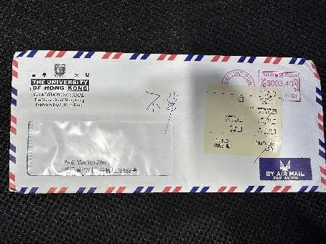
2 | 紫金港 | FANG ZHOU | 866 Yuhangtang Road,XIHU DISTRICT DONG  SAN JIAO XUE LOU  ZHEJIANG UNIVERSITY HANGZHOU ZHEJIANG 310085 CHINA | Asendia  Joe Criesi | 701 Ashland avenue  Flocroft PA 19032  United states | 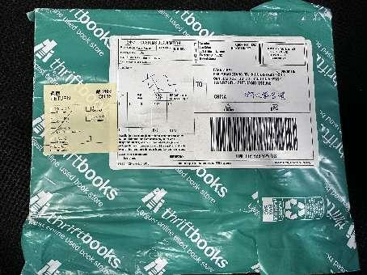
3 | 紫金港 | SHIYI YAN | ZIJINGANG CAMPUS,ZHEJIANG UNIVERSITY,866  YUHANGTANG ROAD. HANGZHOU ZHEJIANG 330009 CHINA | 不详 | 636 EYE STREET NW WASHINGTON,D.C.  20001 | 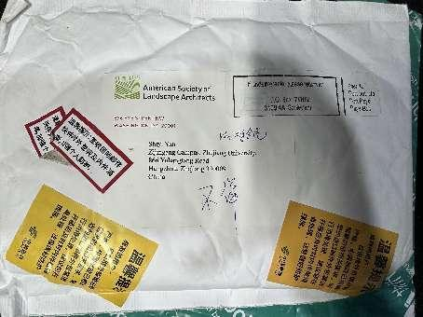
4 | 紫金港 | JIYUAN BAO | 866 RD Yuhangtang DIST XIHU,HangzhouXIHU DISTRICT 310058 CHINA | 不详 | 636 EYE STREET NW WASHINGTON,D.C.  20001 | 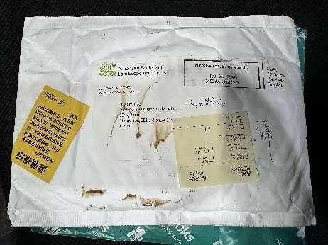
5 | 紫金港 | YU WANG  (王宇） | YUHANGTANG ROAD 866 310058 HANGZHOU CHINA | 不详 | HERTIE SCHOOL FRIEDRICHSTRAL 180 10117 BERLIN | 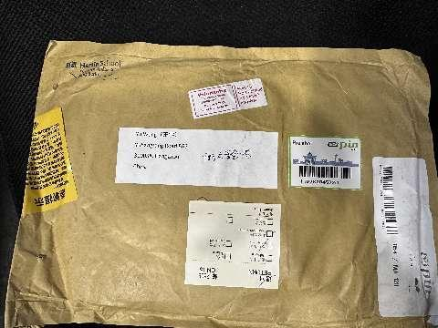
6 | 紫金港 | LIU YUFEI | 866 YUHANGTANG RD. HANGZHOU 310058 CHINA | 不详 | HOKKAIDO UNIVERSITY Public Relations Division Kita 8, Nishi 5, Kita-ku, Sapporo-shi,Hokkaido 060-0808, Japan | 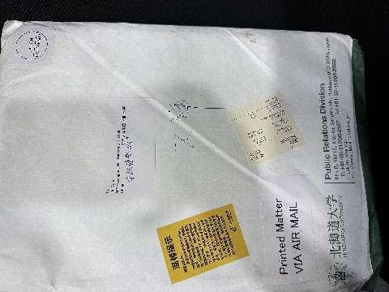
7 | 紫金港 | 不详 | ZHEJIANG UNIVERSITY  866 YUHANGTANG RD. HANGZHOU 310058 CHINA | 不详 | HOKKAIDO UNIVERSITY Public Relations Division Kita 8, Nishi 5, Kita-ku, Sapporo-shi,Hokkaido 060-0808, Japan | 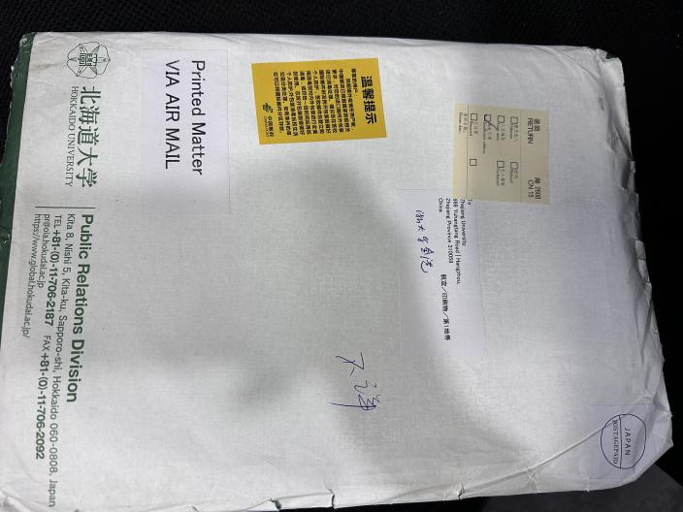
8 | 紫金港 | ZHU QUANWU | 浙江省杭州市西湖区余杭塘路866号 | 不详 | 不详 | 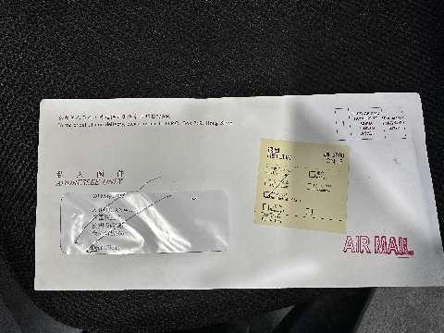
9 | 紫金港 | 郑扬扬小姐 | 中国浙江省杭州市西湖区余杭塘路866号 | 不详 | 不详 | 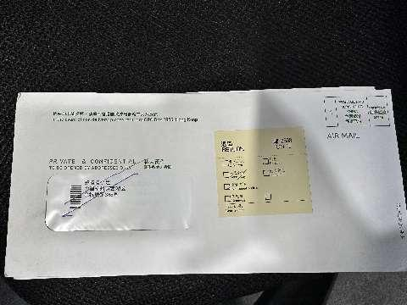
10 | 紫金港 | 王佳 WANGJIA | 中国浙江省杭州市西湖区余杭塘路388号 | 不详 | 不详 | 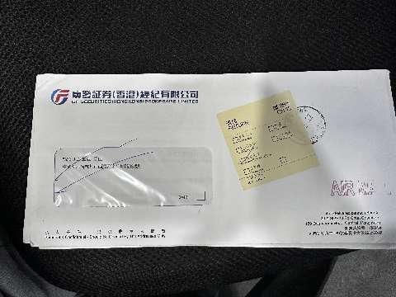
11 | 紫金港 | 范冬梅 | 杭州市西湖区余杭塘路866号 | 不详 | 不详 | 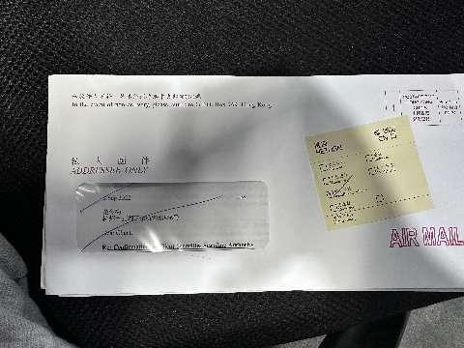
12 | 紫金港 | DONG FANGYUAN | 中国浙江省杭州市西湖区余杭塘路388号 | 不详 | 不详 | 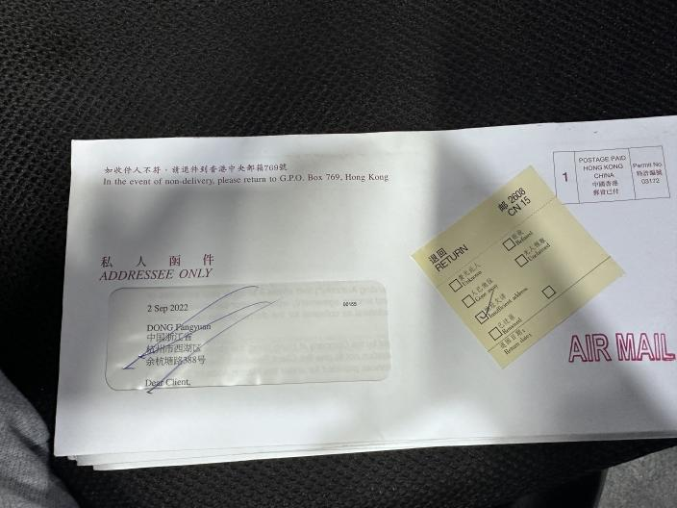
13 | 紫金港 | XUE WENLI | YUHANGTANG 866 ZHEJIANG UNI MENGMINGWEI 160 HZ 310058 CHINA FC00000--000 | 不详 | 不详 | 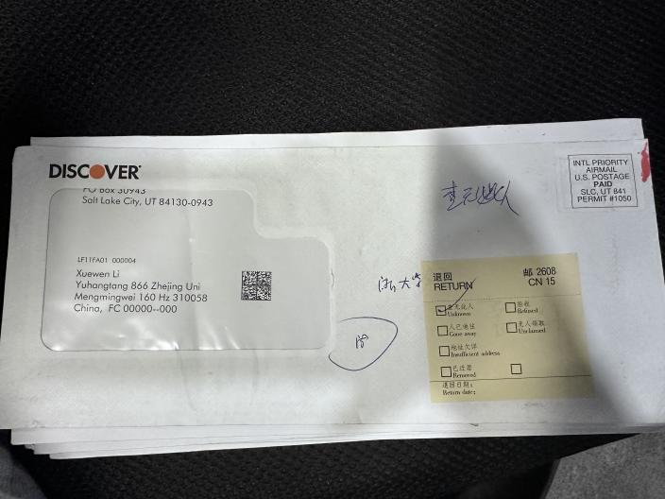
14 | 紫金港 | Scharf Daniel Dr. | ZHEJIANG UNIVERSITY SCHOOL OF BASIC MEDICAL SCIENCES UIJAMGTANG ROAD 866 310058 | 不详 | 不详 | 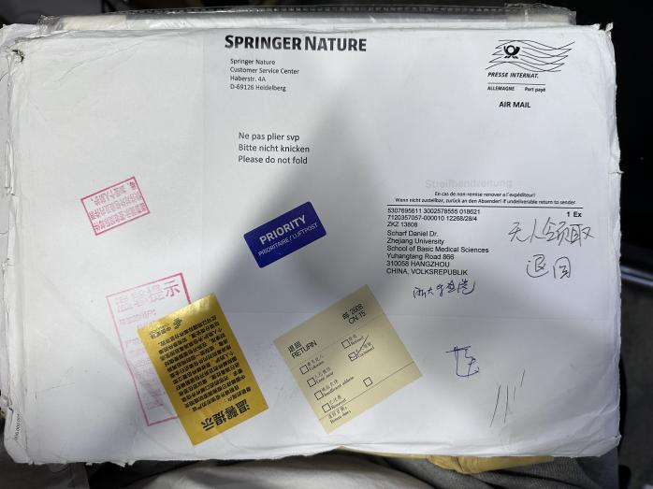
15 | 紫金港 | Scharf Daniel Dr. | ZHEJIANG UNIVERSITY SCHOOL OF BASIC MEDICAL SCIENCES UIJAMGTANG ROAD 866 310058 HANGZHOU CHINA VOLLSTEPUBLIK | 不详 | 不详 | 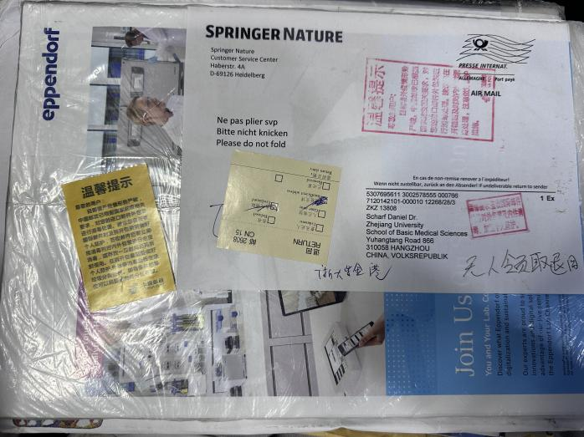
16 | 紫金港 | OUYUAN XU | 杭州市西湖区余杭塘路866号浙江大学白沙又局菜鸟驿站HANGZHOU 310030 CHINA | 不详 | 不详 | 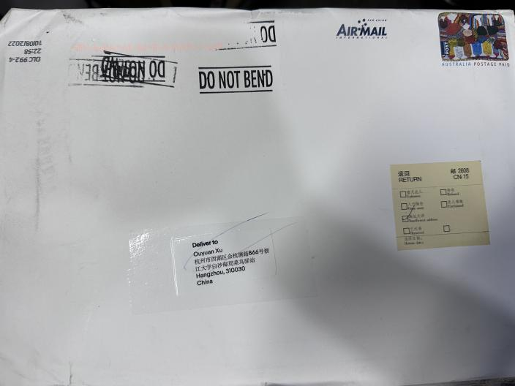
17 | 紫金港 | BIN WU | ZHEJIANG UNIVERSITY 866YUHANGTANG RD XIHU HANGZHOU ZHEJIANG 310027 PR CHINA | 不详 | 不详 | 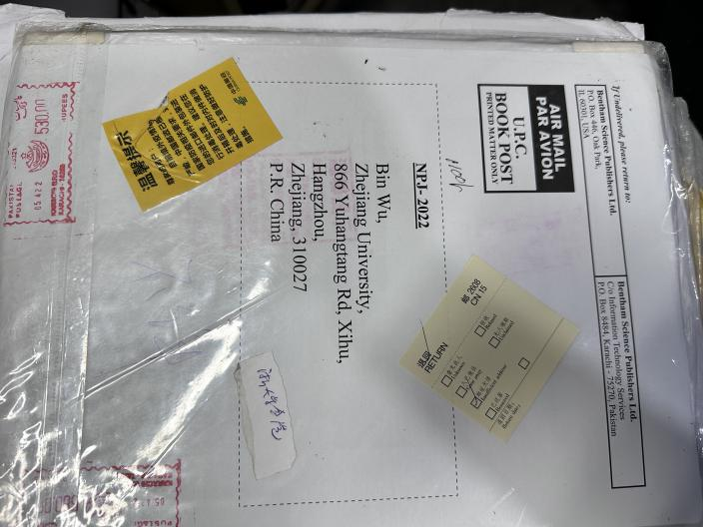
18 | 紫金港 | DR LIU TAO | ZHEJIANG UNIVERSITY 866 YUHANGTANG RD HANGZHOU PR CHINA | 不详 | 不详 | 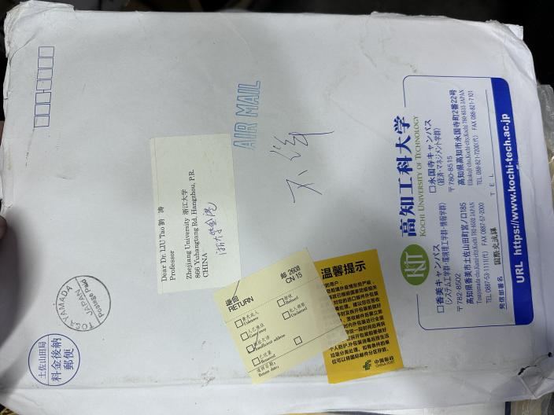
19 | 紫金港 | MA YU | ZHEJIANG UNIVERSITY NO 866 YUHANGTANG RD XIHU DISTRICT HANGZHOU CHINA | 不详 | 不详 | 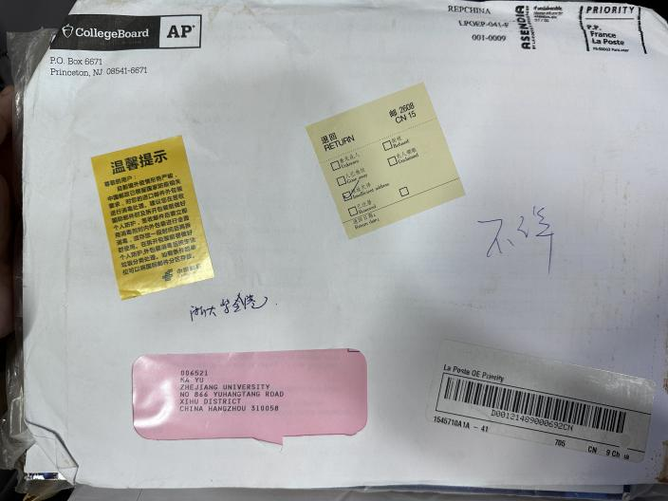
20 | 紫金港 | PROF BIAOYANG LIN | ZHEJIANG UNIVERSITY ZCNI BUILDING ROOM 243 866 YUHANGTANG ROAD HANGZHOU 310058 CHINA 309 | 不详 | 不详 | 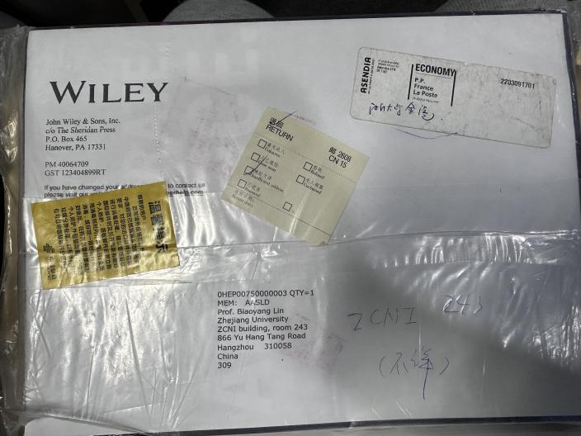
21 | 紫金港 | WEI WU | ZHEJIANG UNIVERSITY HANGZHOU 310058 CHINA | 不详 | 不详 | 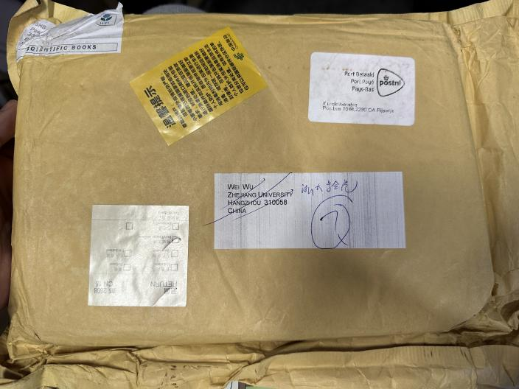
1 | 玉泉8月 | JUNSEN ZHANG | Zhe jiang University NO:38,Zheda Road Hangzhou | 不明 | University of Chicago press subscription fulfillment ,il 60637-2902 | 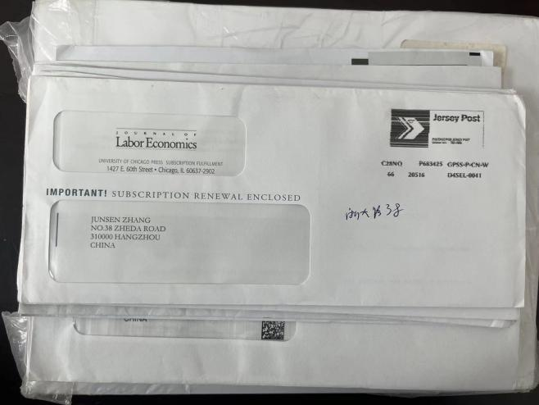
2 | 玉泉 | Dr.Liming Jiang | Zhe jiang University NO:38,Zheda Road Hangzhou | 不明 | American Chemical Society p.o.Box.Columbus,OH43210-0337
2 | 玉泉 | Xiaoming Ma | East China University of Sci and Tech  Teaching B 11  No. 38 Zhada Road Xihu District  Hangzhou 310027 | 不明 | 美国 ACS Chemistry for Life American Chemical Society P.O. Box 3337, Columbus, OH 43210-0337  ELECTRONIC SERVICE REQUESTED | 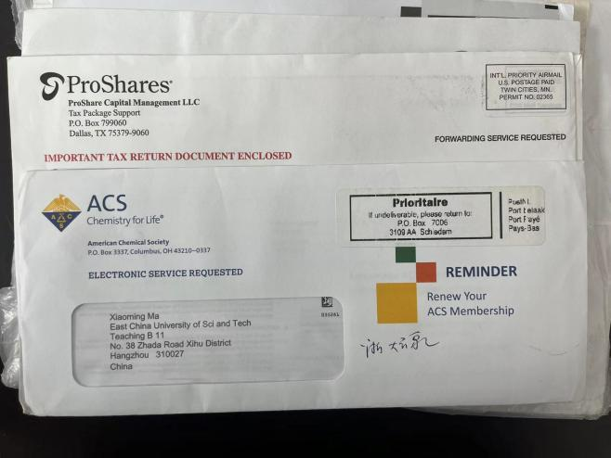
3 | 玉泉 | YUNFENG PANG | No. 38 Zhada Road Xihu District  Hangzhou | 不明 | ProShare Capital Management LLC Tax Package SupportP.O. Box 799060
4 | 玉泉 | Xuhan Mr. Zhang | No. 38 Zhada Road Xihu District  Hangzhou | 不明 | 加拿大
5 | 玉泉 | ZHAO JIA QI | No. 38 Zhada Road Xihu District  Hangzhou | 中银证券 | BOCI SECURITIES LIMITED18/F, LOW BLOCK, GRAND MILLENNIUM PLAZA181 QUEEN'S ROAD CENTRAL HONG KONG
6 | 玉泉 | YUAN, HANGJIE | No. 38 Zhada Road Xihu District  Hangzhou | 不明 | 美国 Rosedale Road PO Box 6666 Princeton, NJ 08541-6666 | 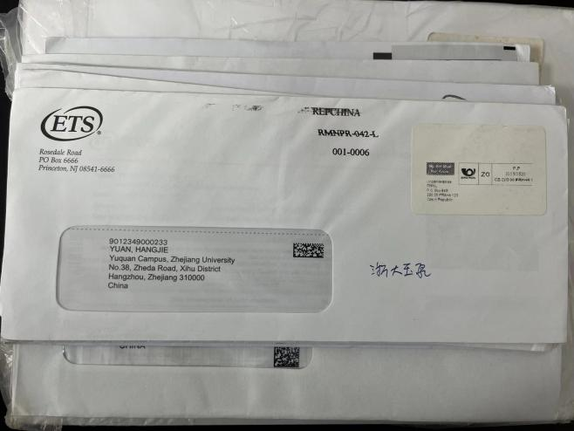
7 | 玉泉 | MISS JENNY CHEN | No. 38 Zhada Road Xihu District  Hangzhou | 不明 | CANADA POST POSTES | 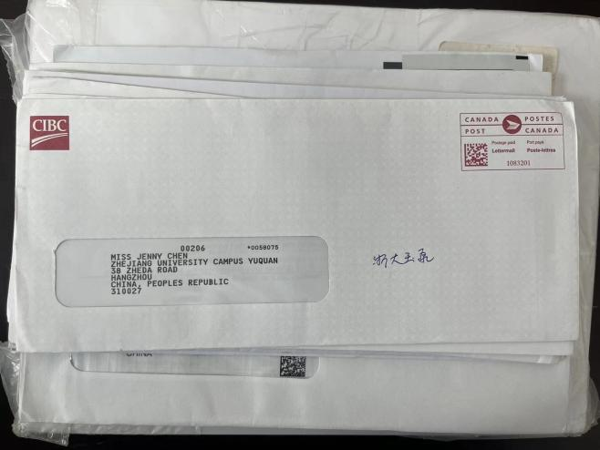
8 | 玉泉 | Yuan Tu | No. 38Zhada Road Xihu District  University Bldg 406 Hangzhou | 不明 | 美国 MIT Federal Credit Union 70 Westview Street Lexington, MA 02421 Phone 617.253.2845 | 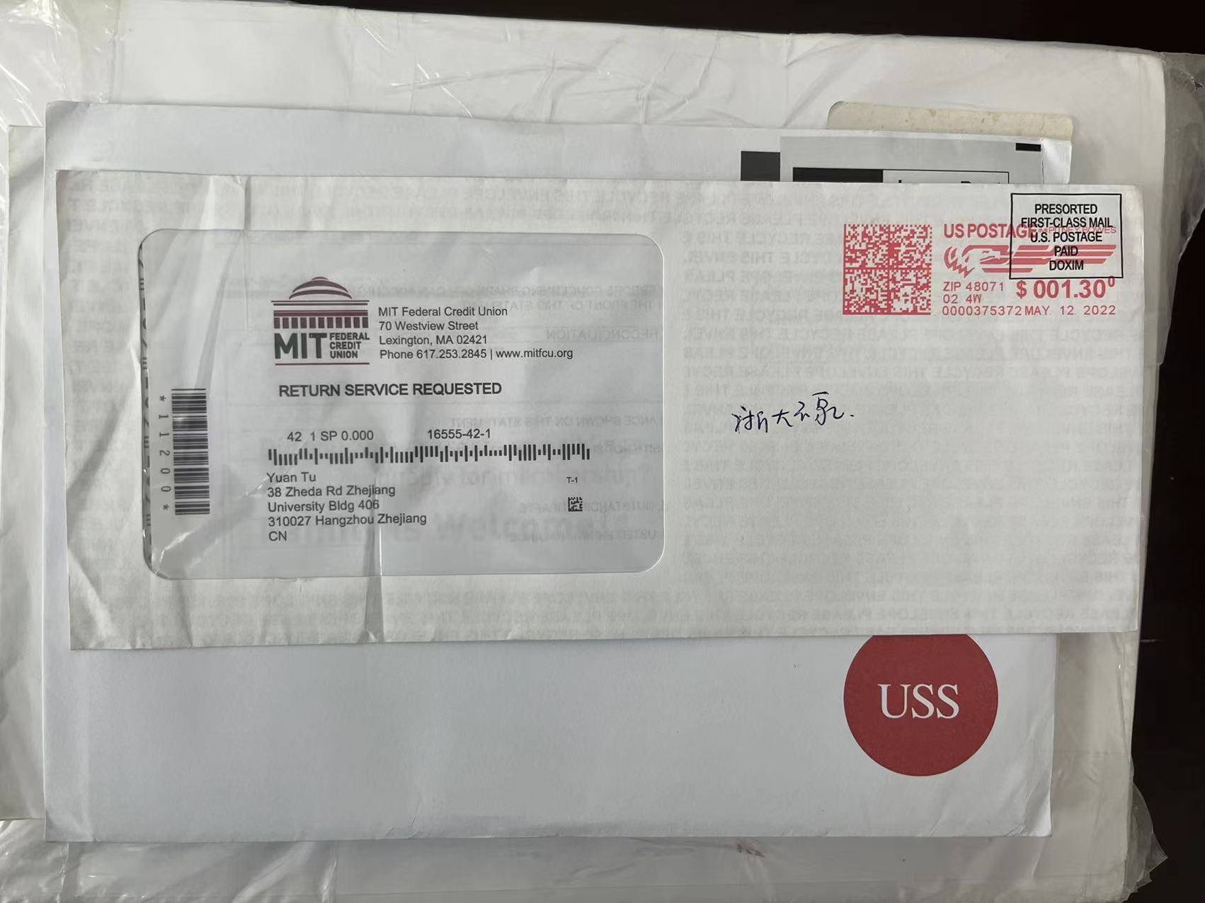
9 | 玉泉 | SHAOPENG ZHU | No. 38 Zhada Road Xihu District  Hangzhou | 盈透证券有限公司 | Interactive Brokers LLC 2 Pickwick Plaza Greenwich, CT 06830 | 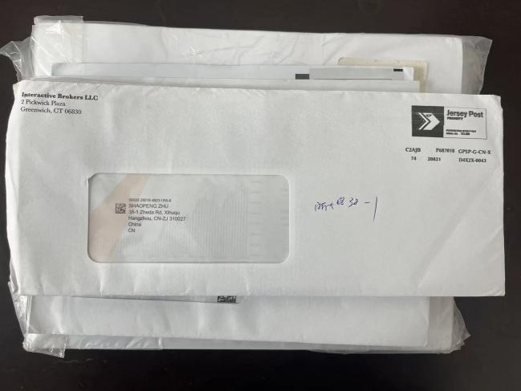
10 | 玉泉 | Mr Huangtianzhi Zhu | No. 38 Zhada Road Xihu District  Hangzhou | 不明 | POSTAGE PAID JERSEY POST SERIAL NO. 920 | 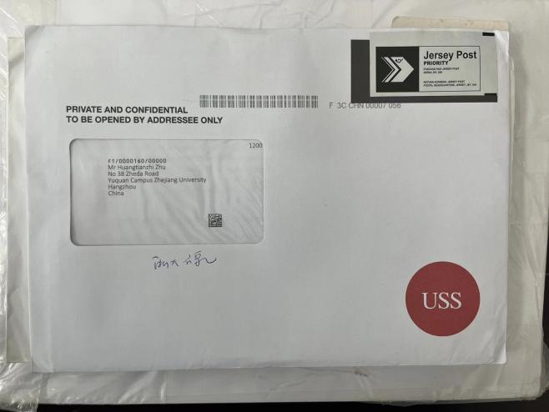
11 | 玉泉 | XU ZHEN QIN | No. 38 Zhada Road Xihu District  Hangzhou | 不明 | ProShare Capital Management LLC Tax Package SupportP.O. Box 799060 | 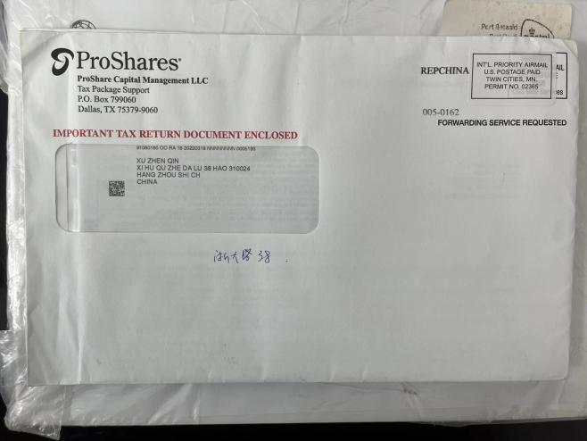
12 | 玉泉 | GUOQIANGZHU | No. 38 Zhada Road Xihu District  Hangzhou | 不明 | ProShare Capital Management LLC Tax Package SupportP.O. Box 799060 | 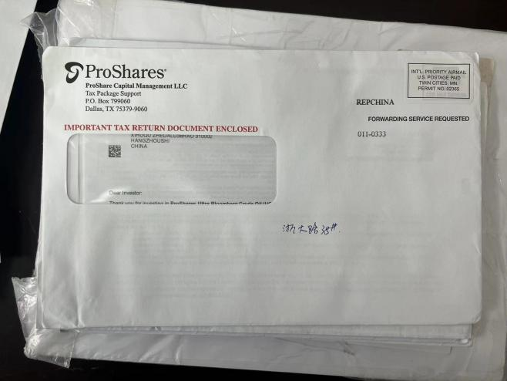
13 | 玉泉 | HUICHUN WU | No. 38 Zhada Road Xihu District  Hangzhou | 不明 | P.O. Box 927 Alhambra, CA 91802-0927 Address Service Requested | 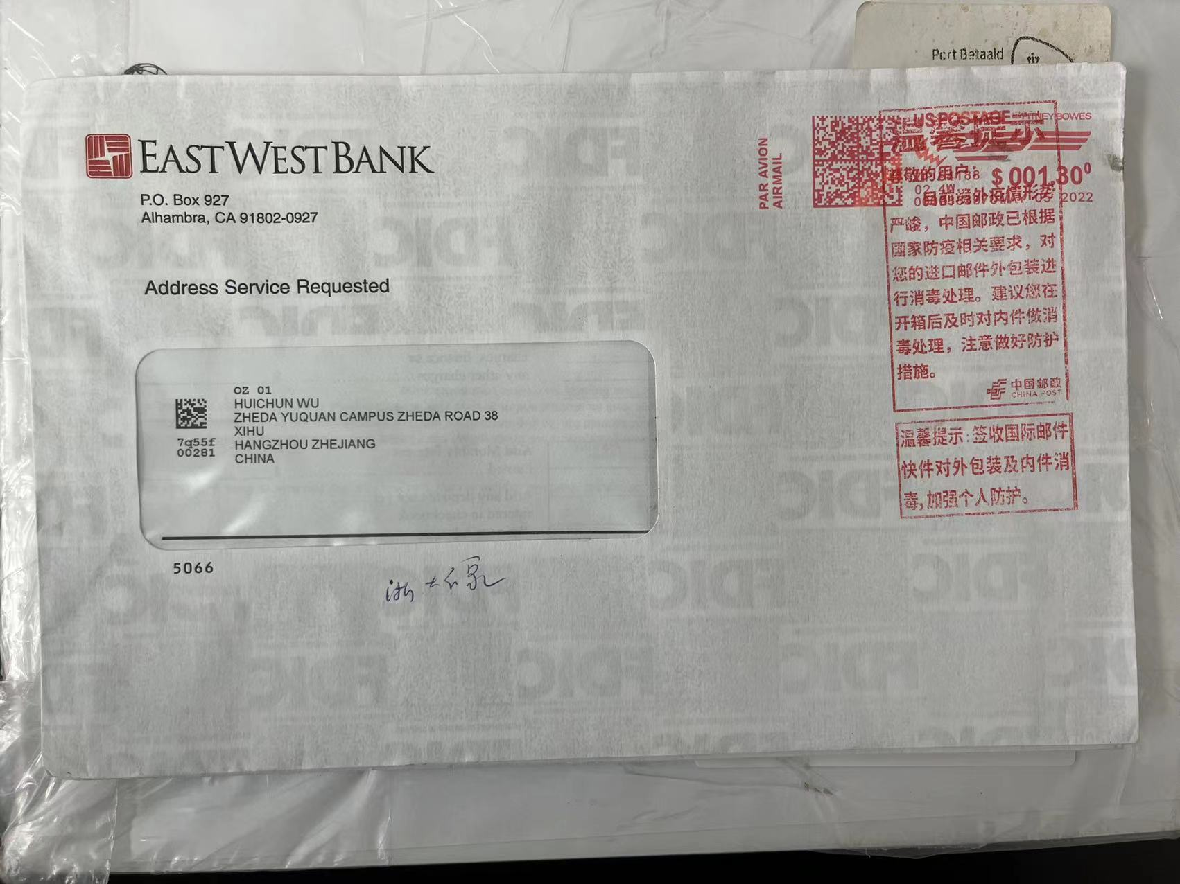
14 | 玉泉 | XUECHAO DU | No. 38 Zhada Road Xihu District  Hangzhou | 不明 | PO Box 261 Bournemouth BH7 7DB United Kingdom | 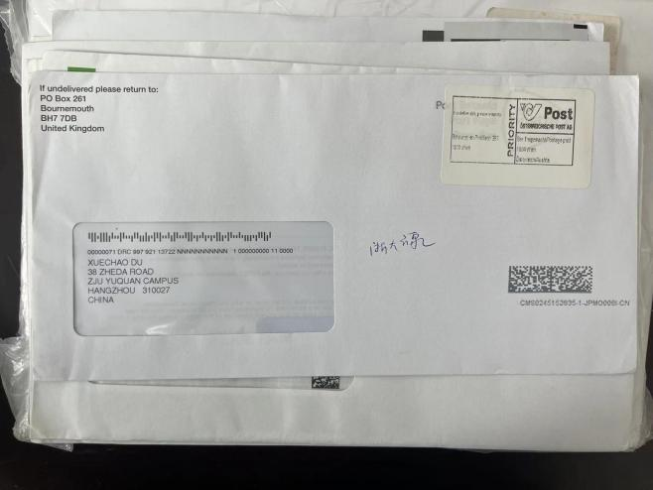
15 | 玉泉 | XUECHAO DU | No. 38 Zhada Road Xihu District  Hangzhou | 不明 | PO Box 261 Bournemouth BH7 7DB United Kingdom | 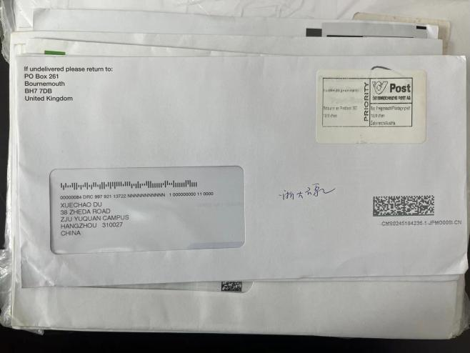
16 | 玉泉 | NINGHAI HUANG | No. 38 Zhada Road Xihu District  Hangzhou | 不明 | ProShare Capital Management LLC Tax Package SupportP.O. Box 799060
17 | 玉泉 | NINGHAI HUANG | No. 38 Zhada Road Xihu District  Hangzhou | 不明 | ProShare Capital Management LLC Tax Package SupportP.O. Box 799060 | 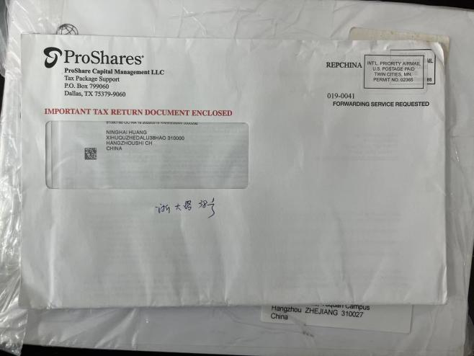
18 | 玉泉 | JIANING CAO | No. 38Zhada Road Xihu District  Hangzhou | 不明 | Bournemouth | 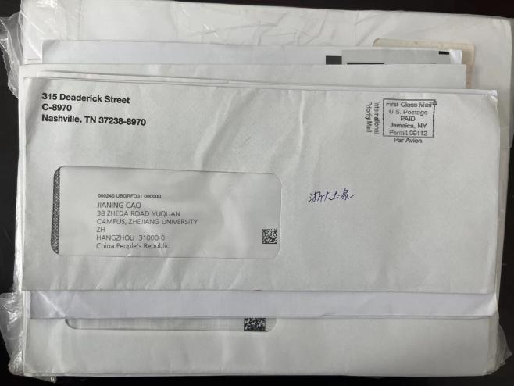
19 | 玉泉 | Shuyi Wang | No. 38 Zhada Road Xihu District  Hangzhou | 不明 | OFFICE OF ADMISSIONS Admissions Processing 0200 TAMU College Station, TX 77843 | 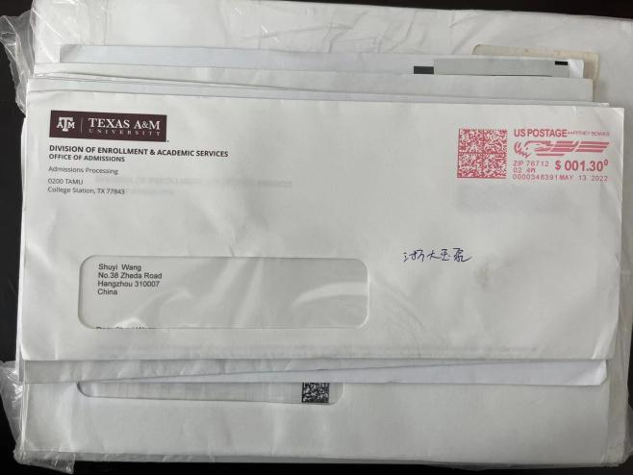
20 | 玉泉 | CHUNHUI HUANG | No. 38 Zhada Road Xihu District  Hangzhou | 美洲证券 | PO BOX 2577 OMAHA, NE 68103-2577 | 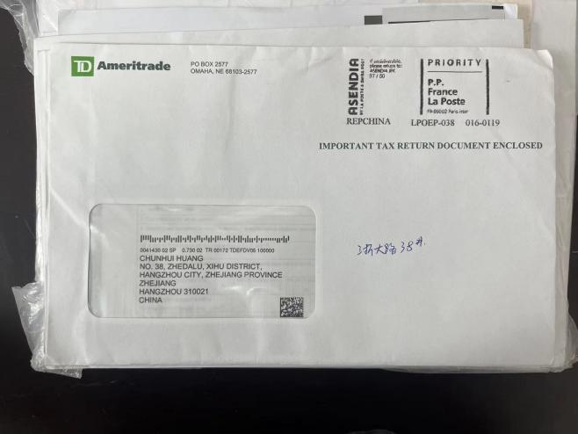
21 | 玉泉 | JIANCHENG QI | No. 38 Zhada Road Xihu District  Hangzhou | 不明 | ProShare Capital Management LLC Tax Package SupportP.O. Box 799060 | 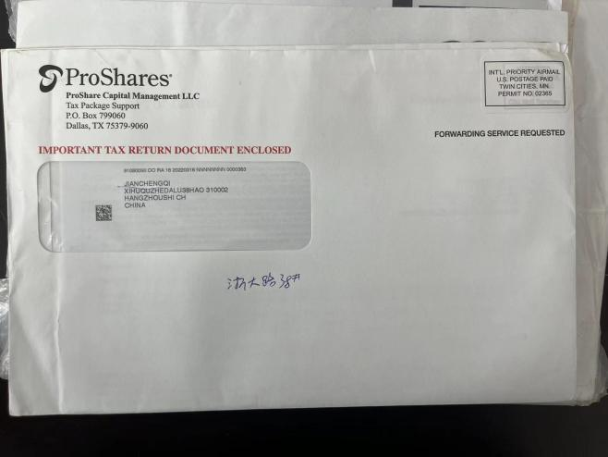
22 | 玉泉 | YUNFENG PANG | No. 39 Zhada Road Xihu District  Hangzhou | 不明 | ProShare Capital Management LLC Tax Package SupportP.O. Box 799060 | 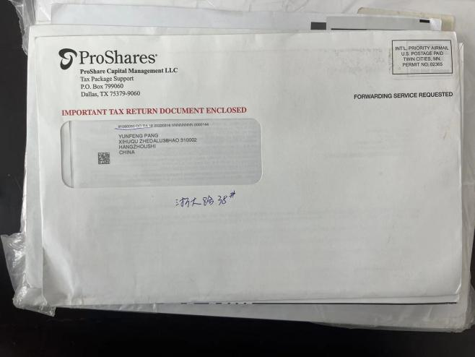
23 | 玉泉 | Baohua JI | No. 38 Zhada Road Xihu District  Hangzhou | ASME | 150 Clove Road 6th Floor Little Falls, NJ 07424 | 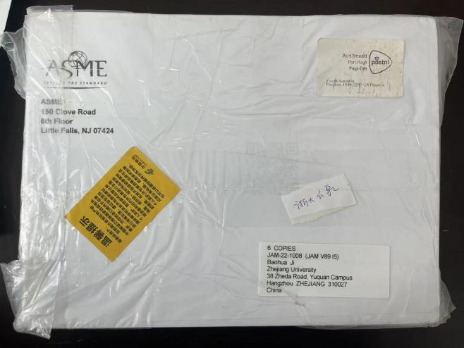
1 | 玉泉9月 | Yong He | Zhejiang university 38 Zheda Road Hangzhou china | 不明 | 不明 | 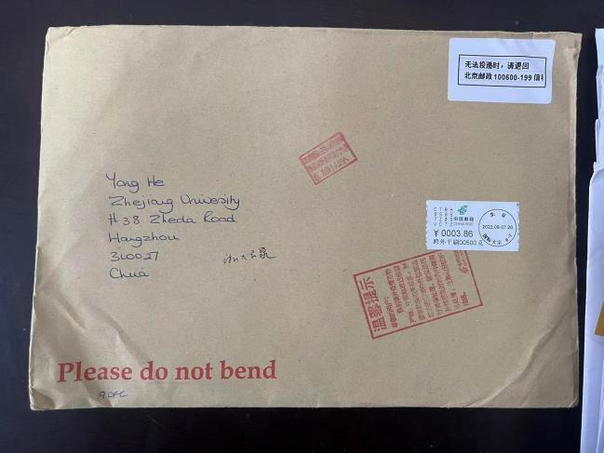
2 | 玉泉 | Ink Wen | Zhejiang university 38 Zheda Road Hangzhou china |  | American Chemical society | 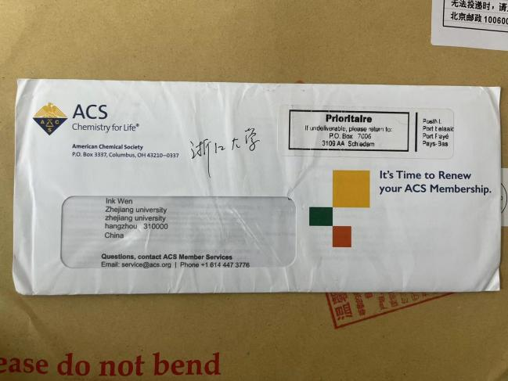
3 | 玉泉 | Ruofei Wang | Zhejiang university 38 Zheda Road Hangzhou china | Inteiactive Brokers LLC | 英国
4 | 玉泉 | WENCHAO MENG | Zhejiang university 38 Zheda Road YuQuan campus Hangzhou china | ELSEVIER INC | 3251 RIBERPORT LANE MARYLANG HEIGHTS MO 63043 加拿大 | 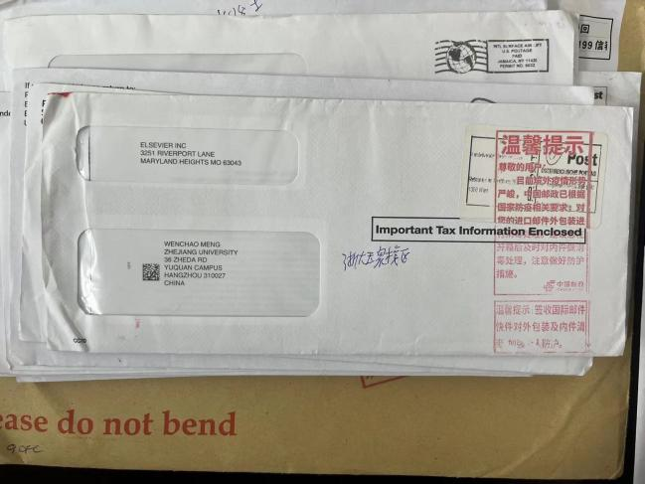
5 | 玉泉 | YIZHENG,XUE | Zhejiang university 38 Zheda Road YuQuan campus Hangzhou china | ETS | TOSEDAL ROAD PO BOX 666 PRINCETON ,NJ 美国 | 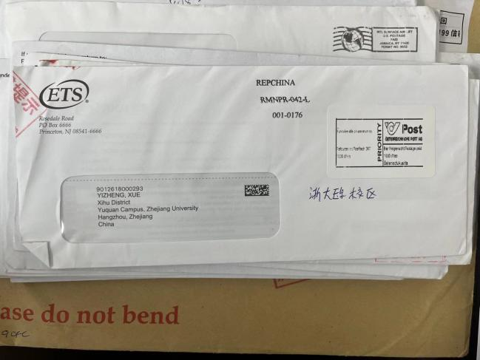
6 | 玉泉 | LIANG,CHENHUI | Zhejiang university 38 Zheda Road YuQuan campus Hangzhou china | ETS | TOSEDAL ROAD PO BOX 666 PRINCETON ,NJ 美国 | 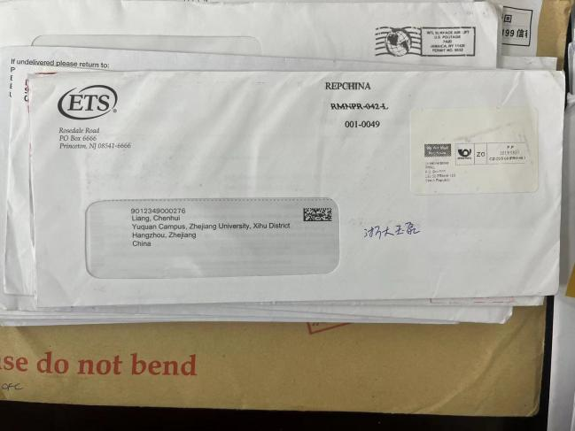
7 | 玉泉 | XUECHAO DU | Zhejiang university 38 Zheda Road YuQuan campus Hangzhou china | 不明 | BORUNEMOUTH BH7 7DB UNITED KINGDOM 英国 | 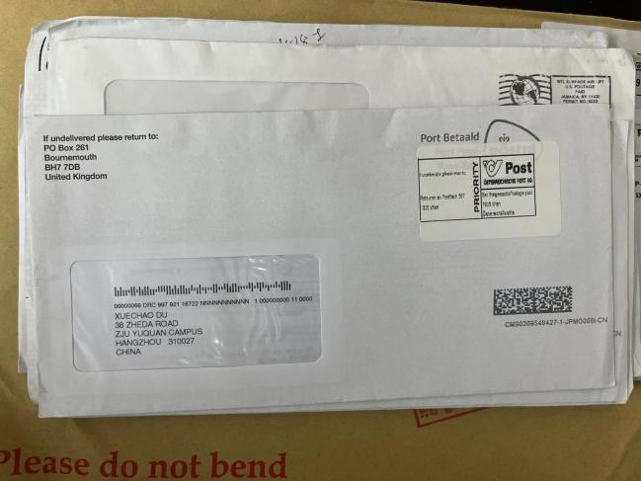
8 | 玉泉 | Dr Liyan Qiu | Zhejiang university 38 Zheda Road YuQuan campus Hangzhou china | ACS | American Chemical society | 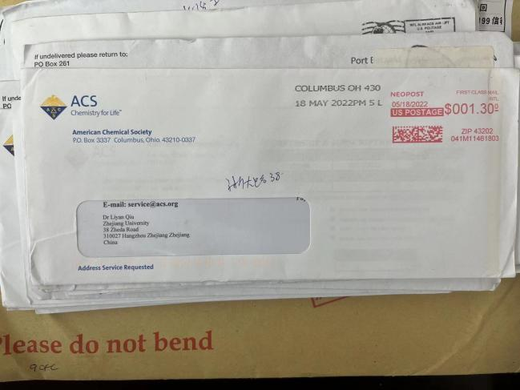
9 | 玉泉 | WANG XIEBIN | Zhejiang university 38 Zheda Road YuQuan campus Hangzhou china | BOCI SECURITIES LIMITED | HONGKONG | 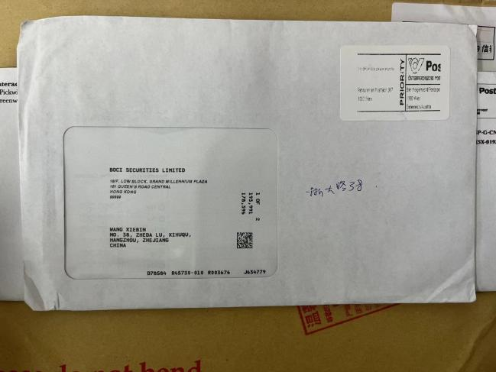
10 | 玉泉 | WAMG CHUNYAN | Zhejiang university 38 Zheda Road YuQuan campus Hangzhou china | 不明 | HONGKONG | 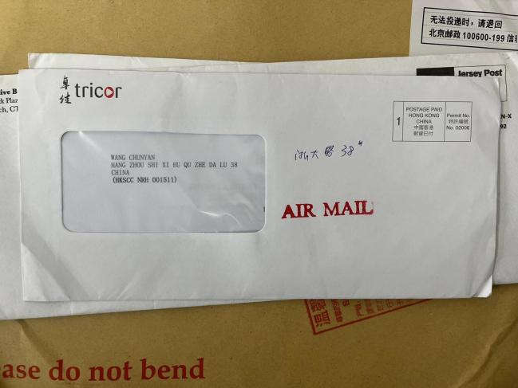
11 | 玉泉 | YAN YONG | Zhejiang university 38 Zheda Road YuQuan campus Hangzhou china | BOCI SECURITIES LIMITED | HONGKONG | 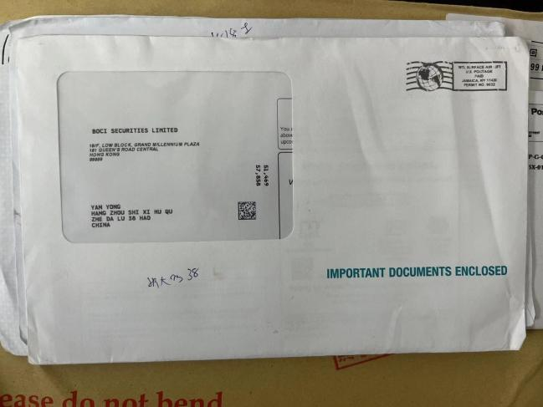
12 | 玉泉 | XUECHAO DU | Zhejiang university 38 Zheda Road YuQuan campus Hangzhou china | 不明 | BORUNEMOUTH BH7 7DB UNITED KINGDOM 英国 | 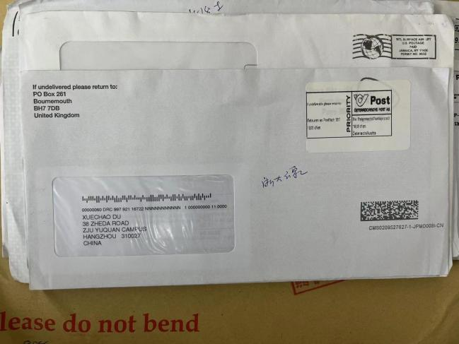
13 | 玉泉 | XUECHAO DU | Zhejiang university 38 Zheda Road YuQuan campus Hangzhou china | 不明 | BORUNEMOUTH BH7 7DB UNITED KINGDOM 英国
14 | 玉泉 | YANGKE XIAO | Zhejiang university 38 Zheda Road YuQuan campus Hangzhou china | ACS | American Chemical society | 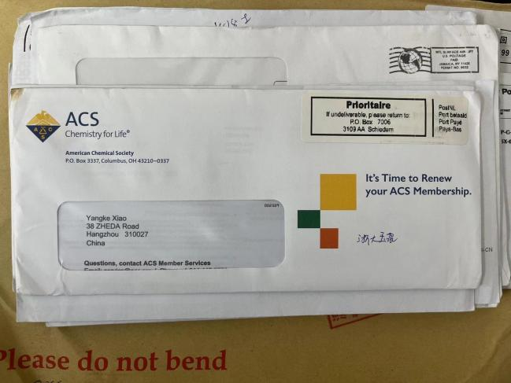
15 | 玉泉 | WANG CHEN | Zhejiang university 38 Zheda Road YuQuan campus Hangzhou china | ETS | TOSEDAL ROAD PO BOX 666 PRINCETON ,NJ 美国 | 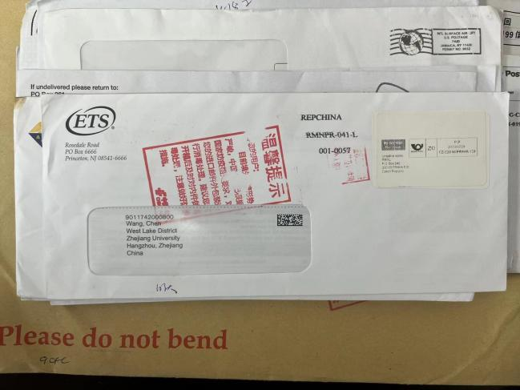
16 | 玉泉 | ZHAO CHAO | Zhejiang university 38 Zheda Road YuQuan campus Hangzhou china | ETS | TOSEDAL ROAD PO BOX 666 PRINCETON ,NJ 美国 | 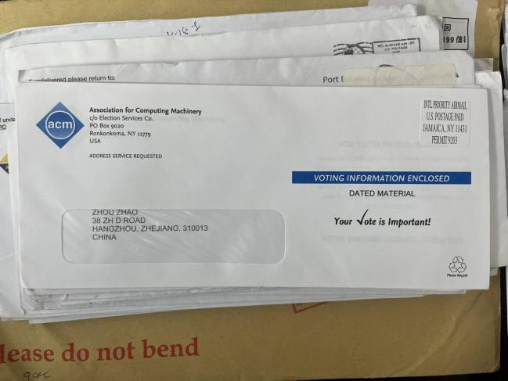
17 | 玉泉 | XUECHAO DU | Zhejiang university 38 Zheda Road YuQuan campus Hangzhou china | 不明 | BORUNEMOUTH BH7 7DB UNITED KINGDOM 英国 | 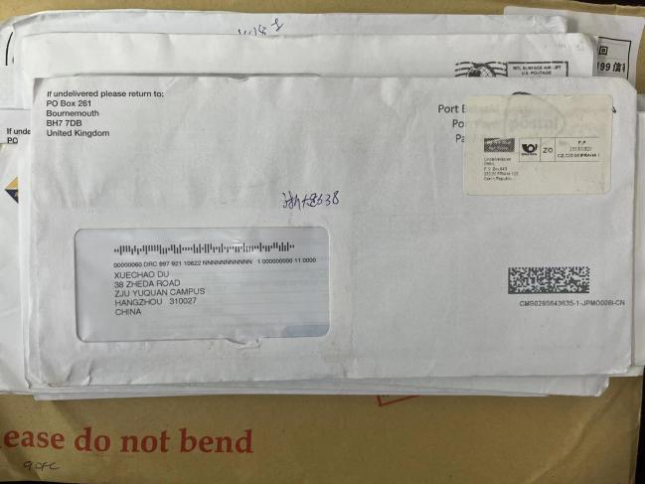
18 | 玉泉 | QING RAN CHEN | Zhejiang university 38 Zheda Road YuQuan campus Hangzhou china | 不明 | OTTAWA 加拿大 | 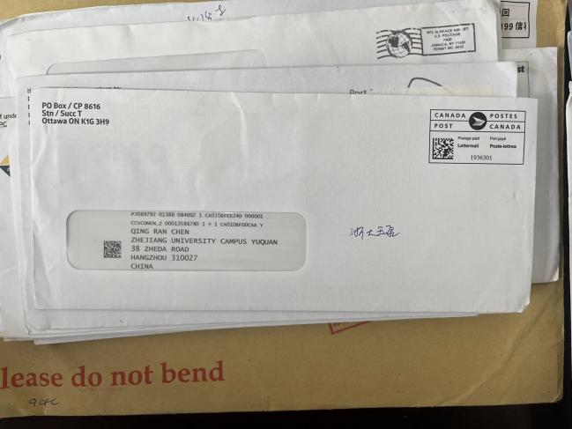
19 | 玉泉 | GHAOJIE GU | Zhejiang university 38 Zheda Road YuQuan campus Hangzhou china | ACM | Association for Computing Machineryc/o Election Services Co.Ronkonkoma, NY 11779 USA | 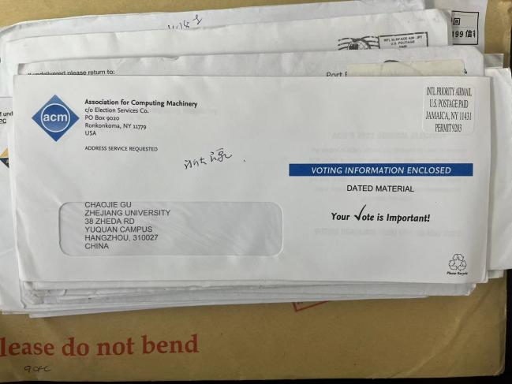
20 | 玉泉 | ZHOU ZHAO | Zhejiang university 38 Zheda Road YuQuan campus Hangzhou china | ACM | Association for Computing Machineryc/o Election Services Co.Ronkonkoma, NY 11779 USA
21 | 玉泉 | WENZHI CHEN | Zhejiang university 38 Zheda Road YuQuan campus Hangzhou china | ACM | Association for Computing Machineryc/o Election Services Co.Ronkonkoma, NY 11779 USA | 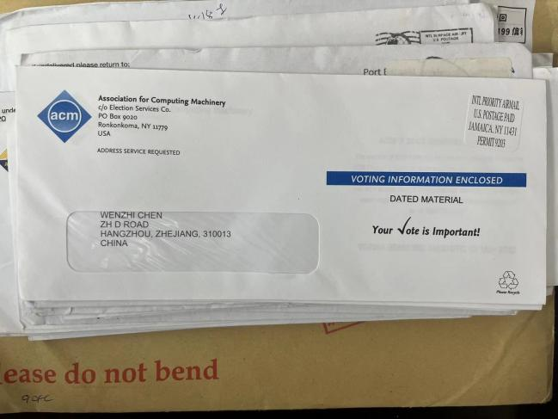
22 | 玉泉 | SHOULING JI | Zhejiang university 38 Zheda Road YuQuan campus Hangzhou china | ACM | Association for Computing Machineryc/o Election Services Co.Ronkonkoma, NY 11779 USA | 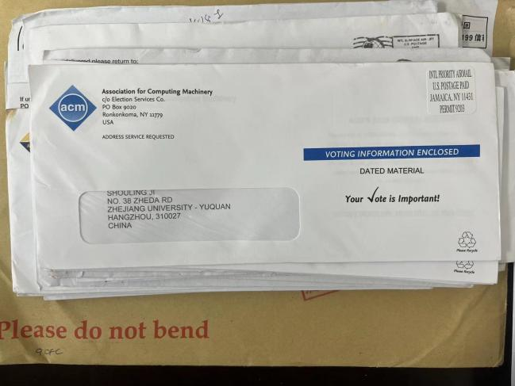
23 | 玉泉 | WEN ZHANG | Zhejiang university 38 Zheda Road YuQuan campus Hangzhou china | ACM | Association for Computing Machineryc/o Election Services Co.Ronkonkoma, NY 11779 USA | 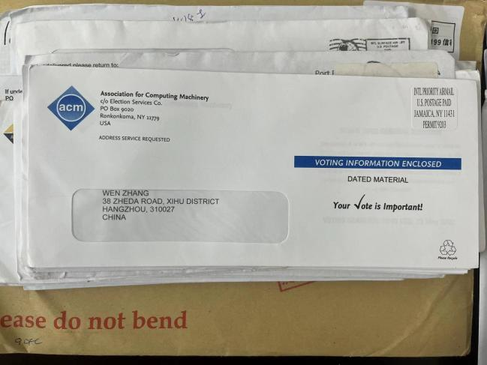
24 | 玉泉 | KAI ZHU | Zhejiang university 38 Zheda Road YuQuan campus Hangzhou china | 不明 | 不明 | 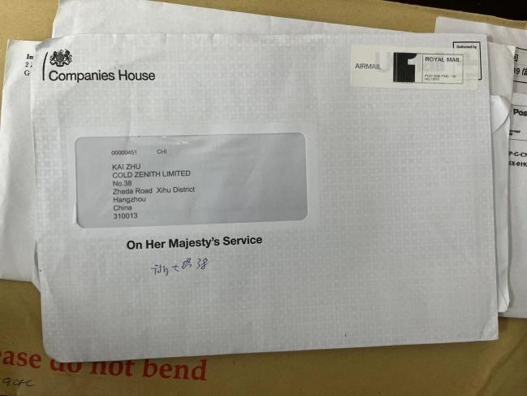
25 | 玉泉 | PROFESSOR X LI FIET | Zhejiang university 38 Zheda Road YuQuan campus Hangzhou china | 不明 | 不明 | 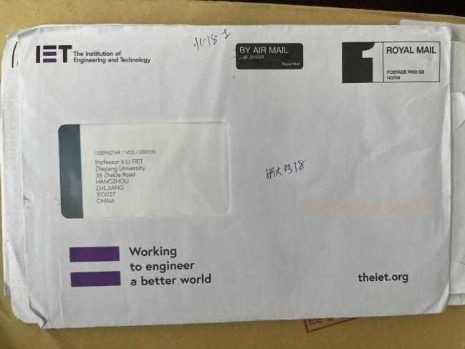
26 | 玉泉 | FEI WU | Zhejiang university 38 Zheda Road YuQuan campus Hangzhou china | ACM | Association for Computing Machineryc/o Election Services Co.Ronkonkoma, NY 11779 USA | 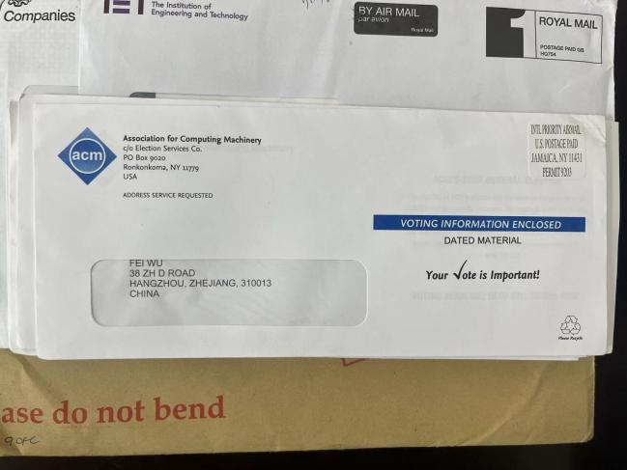
27 | 玉泉 | WANG CHUNYAN | HANGZHOU SHI XIHUQU ZHEDALU 38 CHINA | 中央证劵 | 香港 | 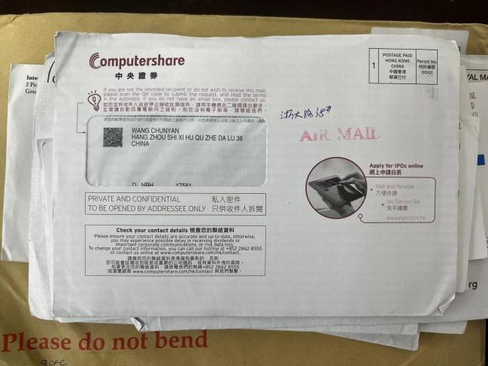
28 | 玉泉 | HUICHUN WU | ZHEDA YUQUAN CAMPUS ZHEDA ROAD 38XIHU HANGZHOU ZHEJIANG CHINA | EAST WEST BANK | 135 N LOS ROBLES AVE PASADENA CA 91101 | 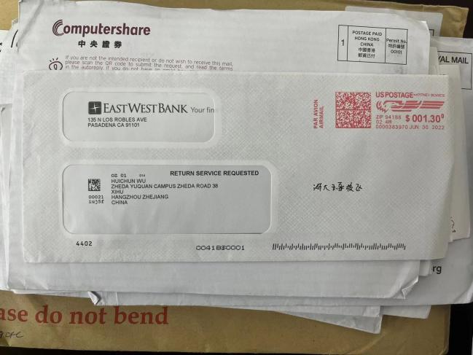
29 | 玉泉 | YATING LIN | ZHEJIANG UNIVERSITY ROAD 38 WESTLAKE DISTRICT YUQUAN CAMPUS HANGZHOU LOWELL 310000CHINA | Northeastern University | Admissions  360 Huntington Avenue  Boston, MA 02115 | 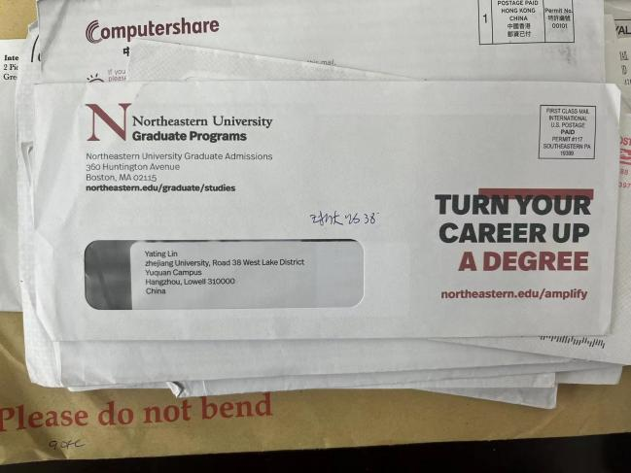
30 | 玉泉 | Dr.Thomas Honold | ZHEJIANG UNIVERSITY ZHEDA ROAD 310027 HANGZHOU VLOKSREPUBLIK CHINA | Allianz | 德国 | 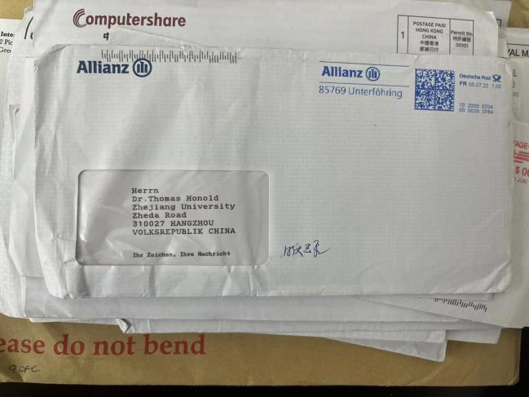
31 | 玉泉 | HU,ZHENGDONG | XINQIAN GATE YUQUAN CAMPUS ZHEJIANG UNIVERSITY HANGZHOU ZHEJIANG 310000 CHINA | ETS | TOSEDAL ROAD PO BOX 666 PRINCETON ,NJ 美国 | 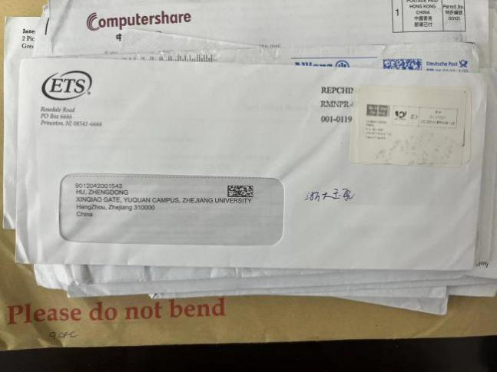
32 | 玉泉 | QING RAN CHEN | 38ZHEDA ROAD HANGZHOU 310027 CHINA | CIBC | CANADA | 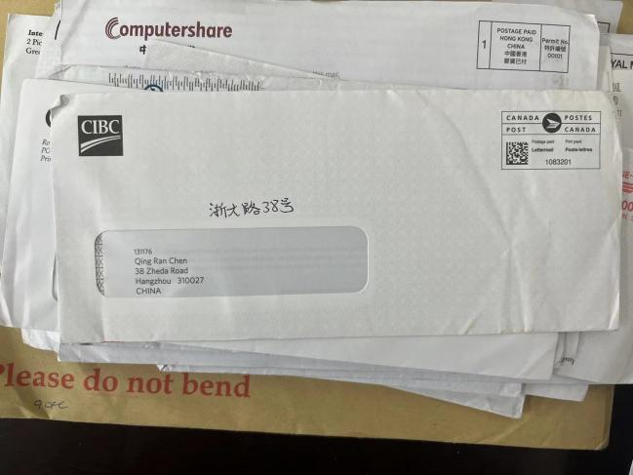
33 | 玉泉 | SUN CHAO | HANGZHOU SHI XIHU QU ZHEDALU 38 HAO CHINA | BOCI SECURITIES LIMITED | HONGKONG | 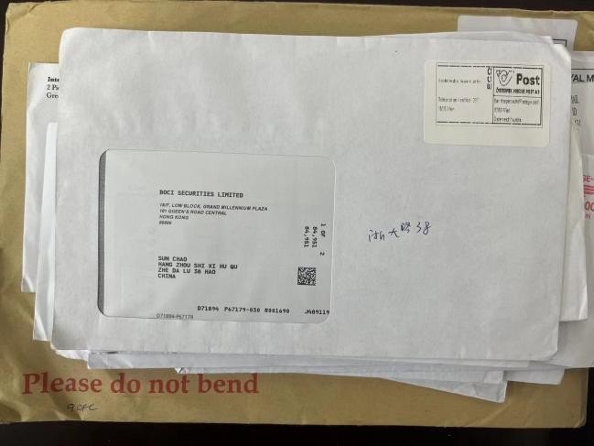
34 | 玉泉 | MINGWEI LIN PH.D | 38ZHEDA ROAD ZHEJIANG UNIVERSITY YUQUAN CAMPUS CHINA 310027 HANGZHOU ZHEJIANG | IEEE | 445 HOES LANE PISCATAWAY NJ 08854 USA | 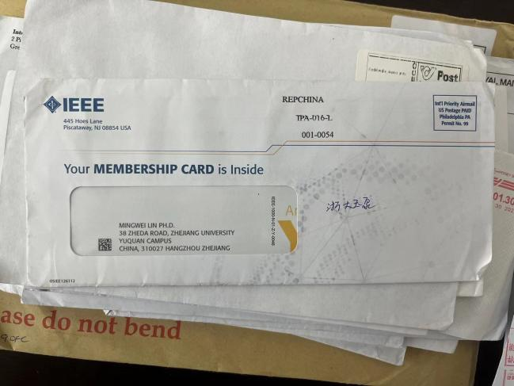
35 | 玉泉 | P.CHEN | ZHEDA ROAD 38 HANGZHOU CHINA | RABOBANK | POSTBUS 301,5600 AH EINDHOVEN 荷兰 | 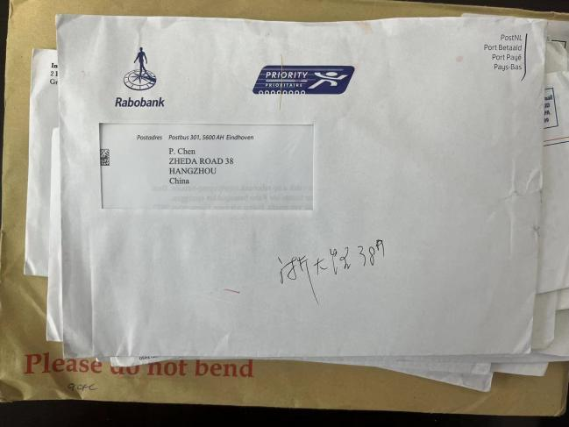
36 | 玉泉 | SHENG ZHOU | NO 38 ZHEDA ROAD HANGZHOU 310007 CHINA | ACM | Association for Computing Machineryc/o Election Services Co.Ronkonkoma, NY 11779 USA | 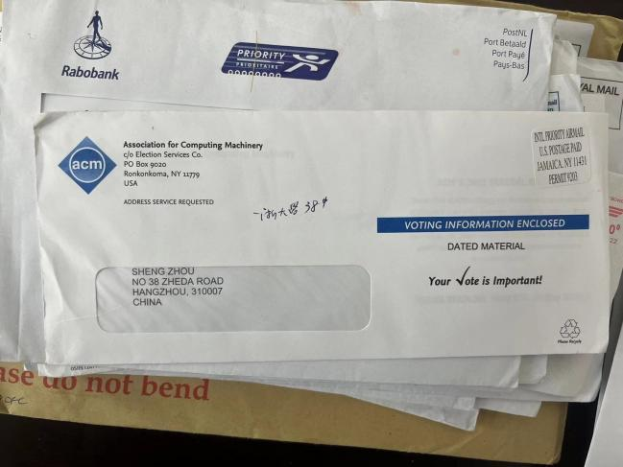
37 | 玉泉 | KE XU | YUQUAN CAMPUS ZHEJIANG UNIVERSITY LINGYIN STREET XIHU DISTRICT HANGZHOU ZHEJIANG PROVINCE CHINA | 香港大学 | 香港 | 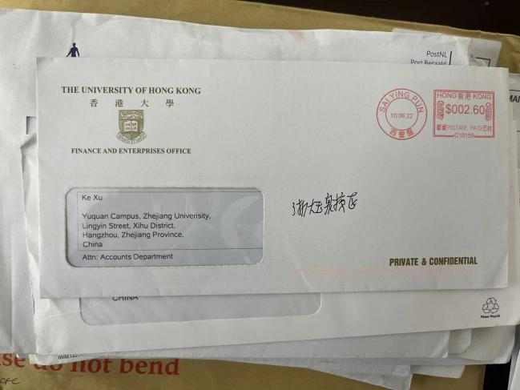
38 | 玉泉 | WUXIN LIU | NO.38 ZHEDA RD.HANGZHOU ZHEJIANG 310027CHINA | APS | American Chemical society | 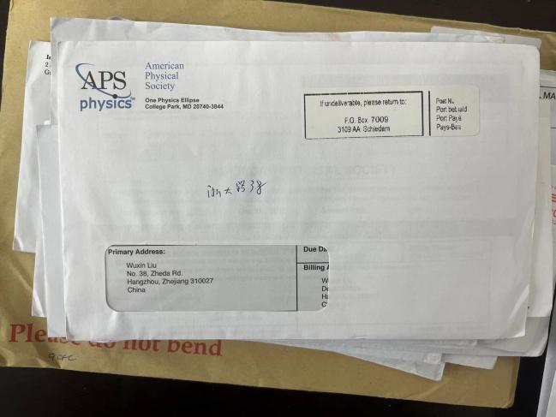
39 | 玉泉 | HUICHUN WU | ZHEDA YUQUAN CAMPUS ZHEDA ROAD 38 XIHU HANGZHOU ZHEJIANG CHINA | EAST WEST BANK | P.O.BOX 927 ALHAMBRA,CA 91802-0927 | 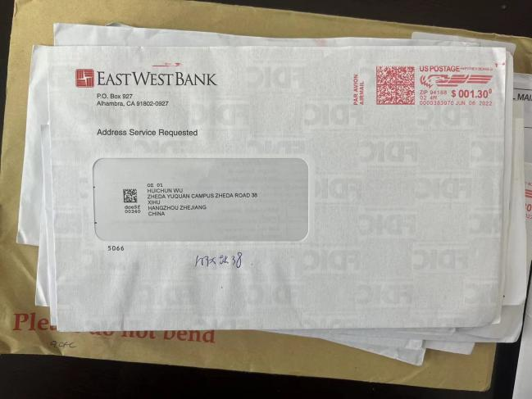
40 | 玉泉 | FENG,YIXIN | YUQUAN CAMPUS ZHEJIANG UNIVERSITY 38ZHEDA ROAD HANGZHOU ZHEJIANG CHINA | ETS | TOSEDAL ROAD PO BOX 666 PRINCETON ,NJ 美国 | 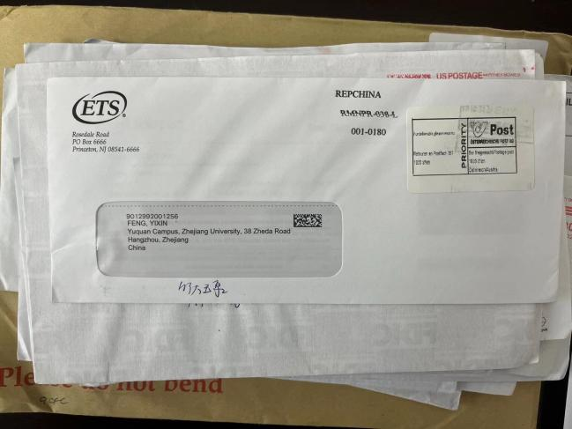
41 | 玉泉 | JIAN WU | 38 ZHEDA ROAD ZHEJIANG UNIVERSITY HANGZHOU 310027 CHINA | ELSEVIER INC | 3251 RIVERPORT LANE MARYLAND HEIGHTS MO 63043 | 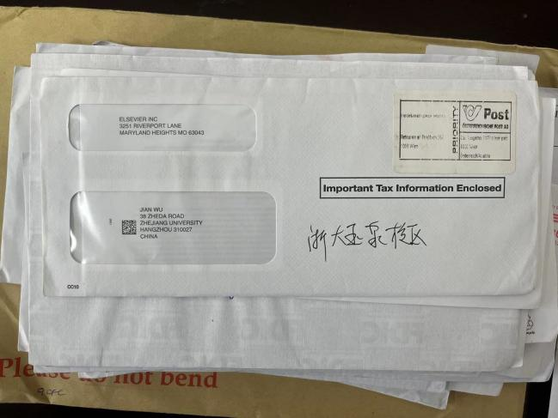
42 | 玉泉 | WANG JINABIN | 中国浙江省杭州市西湖区浙大路38号 邮编310000 | 不明 | Hong Kong | 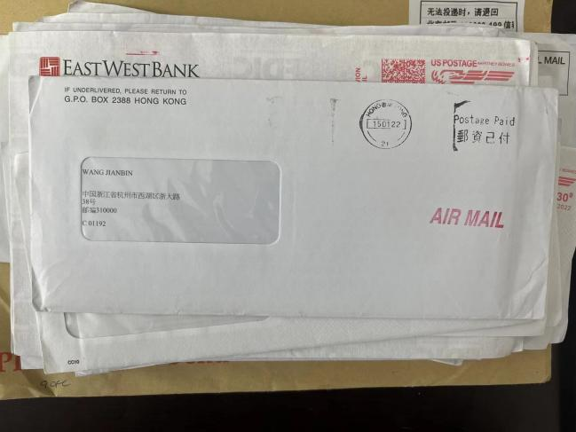
43 | 玉泉 | XIE MIN | ZHEDA ROADN.38 ZHEJIANG UNIVERS.310027 HANGZHOU CINA CINA | 不明 | ITALIANE 意大利 | 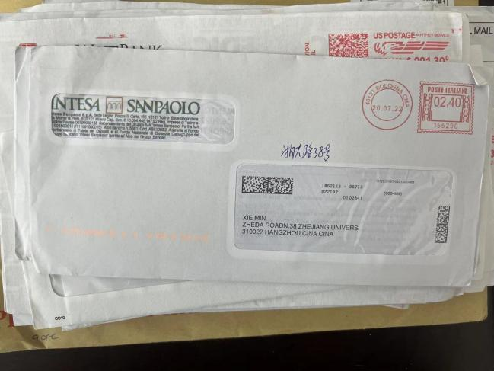
44 | 玉泉 | TONG ZHOU | NO.38 ZHEDA ROAD XIHU DISTRICT HANGZHOU ZJ CHINA 310007 | FIDELITY STOCK | ALBUQUERQUE,NM 87125-8020 美国 | 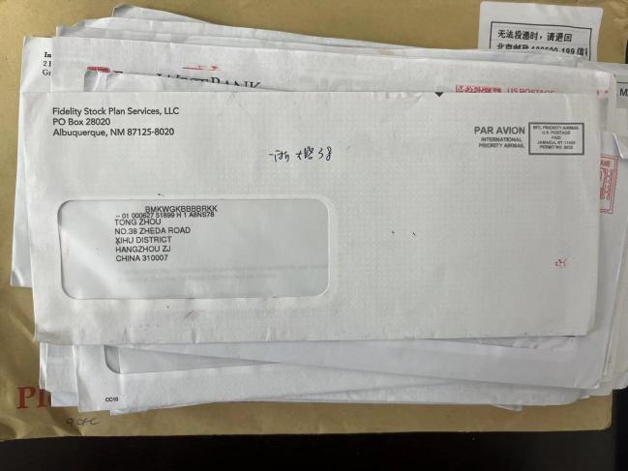
45 | 玉泉 | YIFAN DING | 38TH ZHEDA ROAD HANGZHOU CHINA | US BANK | ST.LOUIS.MO 63166-0524 美国 | 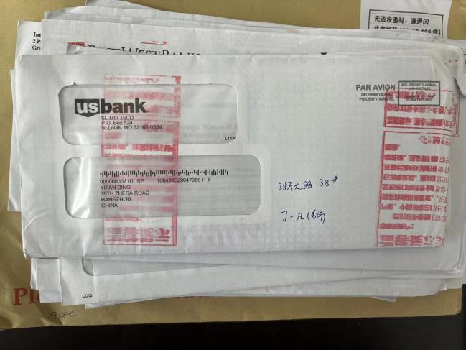
46 | 玉泉 | ZHANG.HAO | ZHEJIANG UNIVERSITY _(+86)310000 CHINA | 不明 | UK | 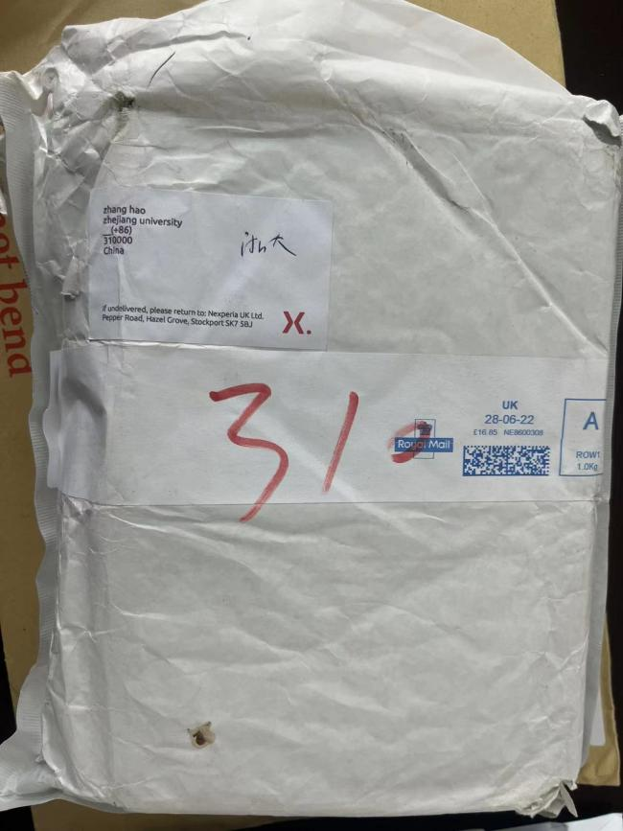
47 | 玉泉 | .不明 | ZheJiang university HangZhou 310027 Zhejiang China | 不明 | John Wiley The Atrium Southen gate Chichester,po198sq UK | 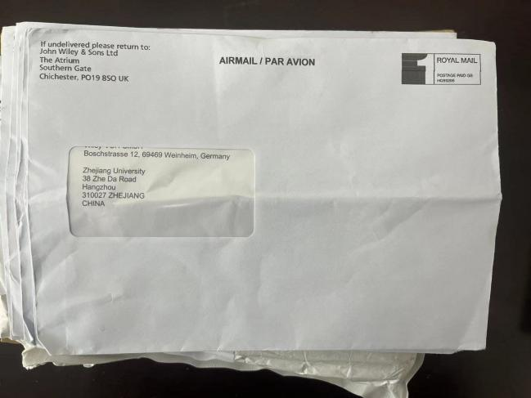
48 | 玉泉 | 不明 | ZheJiang university HangZhou 310027 Zhejiang China | 不明 | John Wiley The Atrium Southen gate Chichester,po198sq UK | 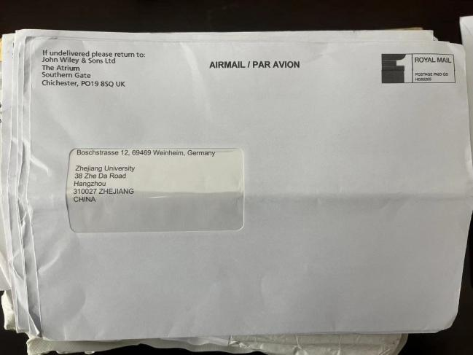
49 | 玉泉 | 不明 | ZheJiang university HangZhou 310027 Zhejiang China | 不明 | John Wiley The Atrium Southen gate Chichester,po198sq UK | 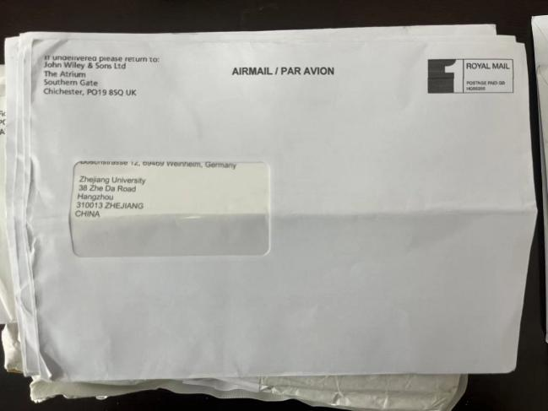
50 | 玉泉 | 不明 | ZheJiang university HangZhou 310027 Zhejiang China | 不明 | John Wiley The Atrium Southen gate Chichester,po198sq UK | 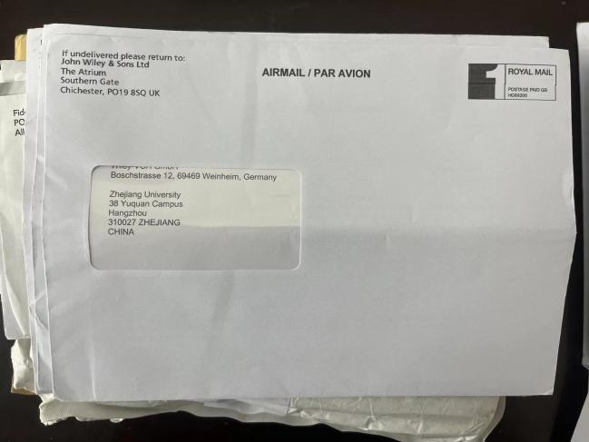
51 | 玉泉 | 不明 | ZheJiang university HangZhou 310027 Zhejiang China | 不明 | John Wiley The Atrium Southen gate Chichester,po198sq UK | 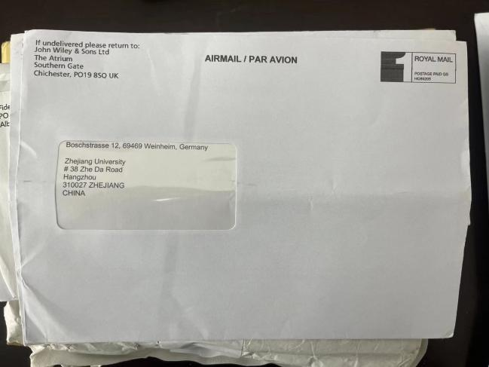
52 | 玉泉 | 不明 | ZheJiang university HangZhou 310027 Zhejiang China | 不明 | John Wiley The Atrium Southen gate Chichester,po198sq UK | 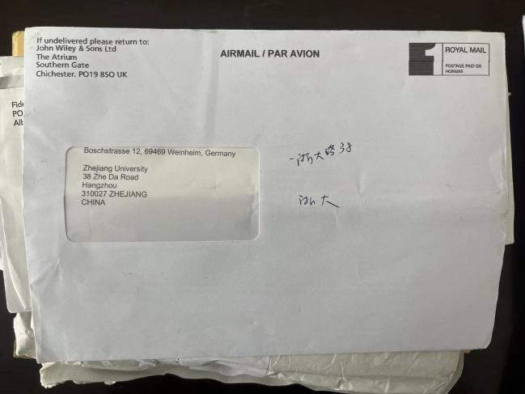
53 | 玉泉 | QIANGQIANG YAN | ROOM 201 NO 38 ZHEDA RD XIHU DISTRICT HANGHZOU | FIDELITY STOCK PLAN SERVICES | ALBUQUERQUE,NM 87125-8020 美国 | 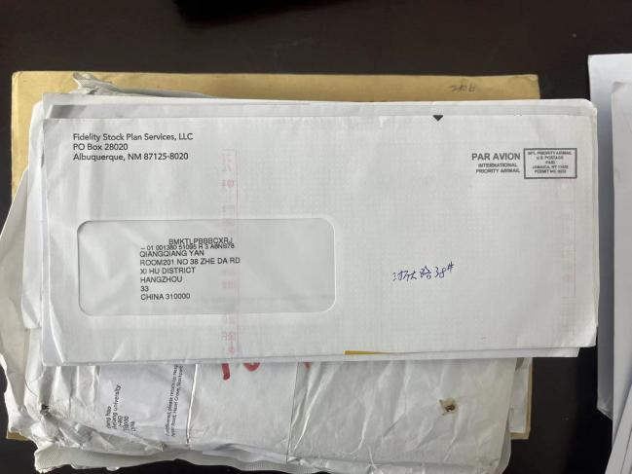
54 | 玉泉 | MR QIU QILONG | Zhejiang university 38 Zheda Road YuQuan campus Hangzhou china | 不明 | HONGKONG | 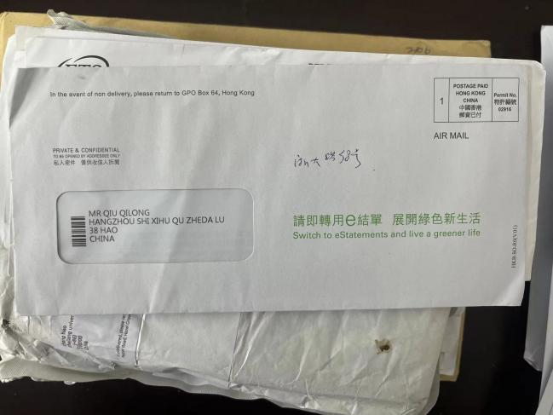
55 | 玉泉 | HU,CHENXI | Zhejiang university 38 Zheda Road YuQuan campus Hangzhou china | ETS | ROSEDALE ROAD PO BOX 666 PRINCETON,NJ 08541-6666 | 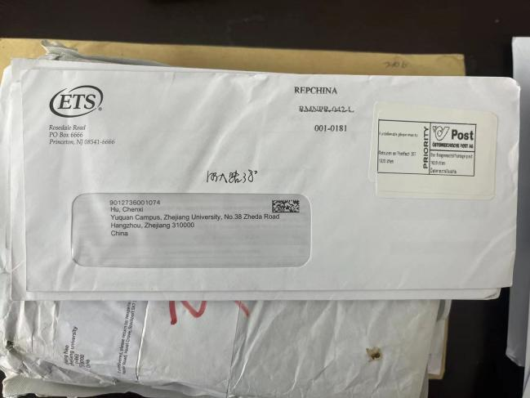
56 | 玉泉 | ZHANGFENG JIN | Zhejiang university 38 Zheda Road YuQuan campus Hangzhou china | MIT PRESS JOURNALS | ONE BROADWAY FLOOR 12 CAMBRIDGE,MASSACHUSETTS 02142-1189 | 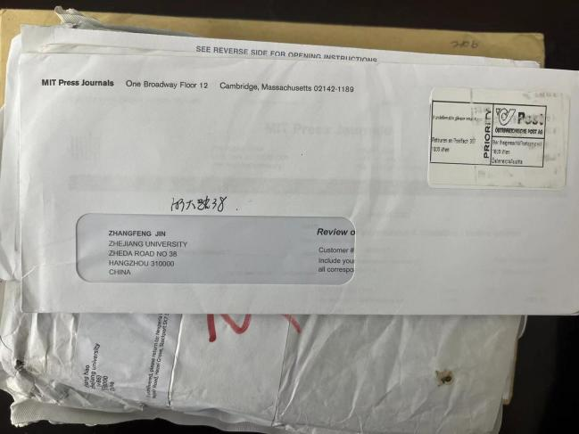
57 | 玉泉 | ZHANGFENG JIN | Zhejiang university 38 Zheda Road YuQuan campus Hangzhou china | MIT PRESS JOURNALS | ONE ROGERS STREET CAMBRIDGE,MASSACHUSETTS 02142-1209 | 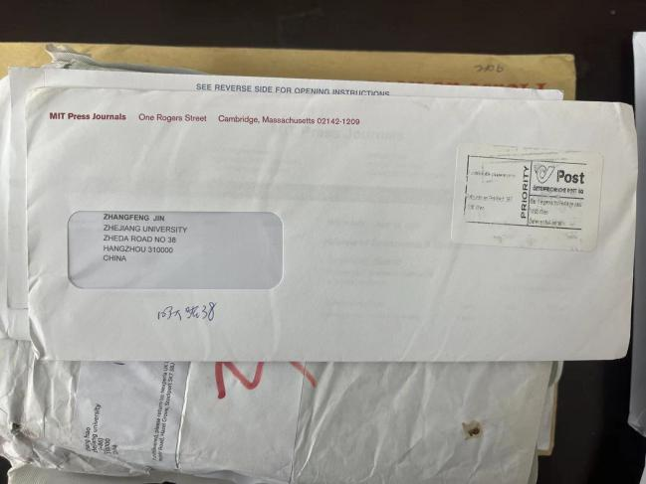
58 | 玉泉 | QING RAN CHEN | Zhejiang university 38 Zheda Road YuQuan campus Hangzhou china | 不明 | RORONTO | 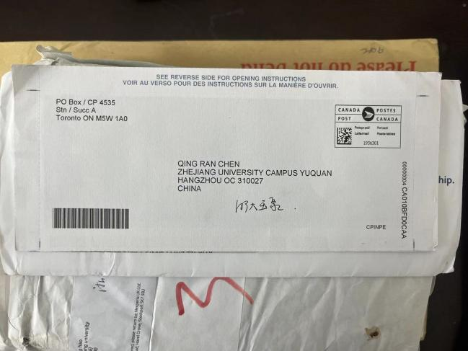
59 | 玉泉 | YANJIE FANG | Zhejiang university 39 Zheda Road YuQuan campus Hangzhou china | ACS | American Chemical society | 